Print this return authorization and include a copy in your return package
FOR AMAZON.COM USE ONLY:
DSK73cP4RRMA
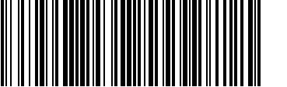

Date: July 20, 2010
Order ID: XXX-XXXXXXX-4437059

Title: Oster Professional 76023-510 Fast Feed Clipper with Adjustable Blade
Quantity: 1
Reason: Defective/Does not work properly
Return Details: I used the clippers for the first time yesterday and the blade adjustment lever just spun freely. It looks like a small piece of the plastic lever that engages the blade had been broken off.
Action Requested: Replacement

Print this mailing label and affix to your return package
No additional postage necessary

- This return label is only valid for this return authorization and may not be used to return any other merchandise

cut or fold the label along this line and affix to the outside of the package

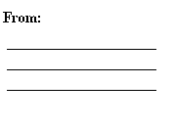 | 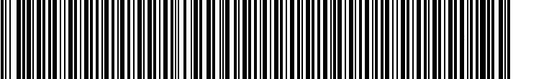 |  | 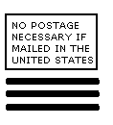
 | 7 05 00 334 01 AMZN 0 3 010258950100 9

 |  | 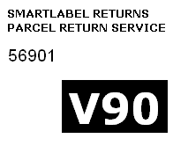
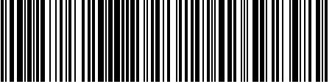
420 56901 9158 1372 0226 8058 9355 61
DSK73cP4RRMA

Additional Instructions for mailing your package

- Print this page.
- Cut out the Return Label and the separate barcode for Amazon use.
- Write your return address in the space provided in the upper-left corner of the label, after the word "FROM."
- Securely pack the items to be returned in a box and include the separate barcode in the package.
- Affix the mailing label squarely onto the address side of the parcel, covering up any previous delivery address and barcode without overlapping any adjacent side.
- Give the package to your letter carrier or take the package to your nearest post office for delivery. No postage is necessary if the package is mailed from within the United States.

