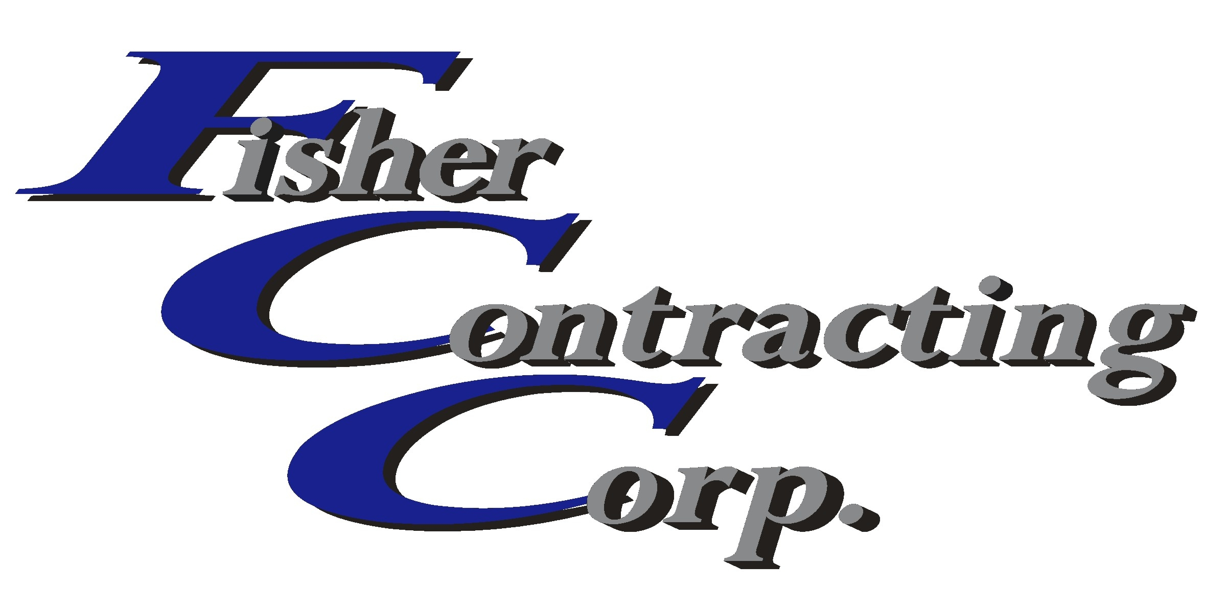
Certified General Contractor CGC 1505947

Invitation to Bid
Project: Subway
901 Southern Blvd.
West Palm Beach, FL

Bids due: Wednesday, July 03, 2013 at 2:00 pm

Alternate Pricing: Alt. # 1 installation of undercounter refrigeration unit 33 on equipment schedule
Alt,. # 2 (2) Drywells – (1) for AC units; (1) for cooler Freezer Units (Condeasate lines to units by AC Contractor.
Alt # 3 Installation of refrigeration for Norlake Direct evaporation cooler and freezer
Alt # 4 Installation of Norlake Direct evaporation cooler and Freezer Floor walls and ceiling panels.
Partial Scope Clarification:
This clarification’s intent to make clear areas of work to be included in your bid, which may not be shown only on plumbing drawing. This drawing set consists of (9) civil drawings, (1) Landscape Drawing (10) architectural drawing; (1) life safety drawing; (2) plumbing; (2) HVAC (2) electrical drawings and (1 Photometric drawing, This project is a ground up new free standing building.

HVAC contractor: must review drawings C-4, A2.1, A2.2, 2.4, A3.1,A6.1 S1.1, S2. AC-1, AC-2 and E2.1. as well as “Modifications to Bid Documents folder, specifically Modification 01 which adds (1) Roof Mounted Exhaust fan in Service 102. Provide a material allowance fan and duct work. Also On sheet A2.2 where the equipment legend indicates work supplied and or installed by GC, what they are saying is furnished and or installed by HVAC Contractor as paid for by GC.

Contact: Bill Christensen, Fisher Contracting Corp.
Phone: 561.691.4716 Fax: 561.691.4718
Email: bc@fishercontracting.net

