INSTALLATIONS
MANUAL V.4



© Water4gasuk Limited 2008

www.water4gasuk.com
Email enquiry@water4gasuk.com

INSTALLATIONS MANUAL
THIS INSTALLATIONS MANUAL REMAINS THE PROPERTY OF WATER4GASUK LTD AND AT NO TIME SHOULD IT BE REPRODUCED.

PLEASE ALWAYS ENSURE YOU HAVE THE MOST RECENT VERSION OF THE MANUAL

Before installing the system read through the manual thoroughly paying special attention to the safety precautions which are highlighted in the yellow boxes throughout the manual.

SAFETY PRECAUTIONS
There are certain mandatory precautions and safety measures, such as the length of hose, the protection from excessive heat and other factors that MUST be adhered to for your safety, the safety of you, your staff and the safety of the customer.
It is strongly recommended that you read the manual thoroughly prior to making and installing the systems.
- Our system is inherently safe. However, like any other system, incorrectly installing or using it may result in serious damage or bodily injury. It is therefore important to read and follow the instructions and safety precautions given within this Manual.
- Work in a well ventilated area, allow no smoking and make sure the engine is switched off and is not hot.
- Wear goggles and gloves. Use general safety procedures standard in automotive installations and maintenance guides. Stainless steel is sharp.
- In case of query, firstly refer to the section on troubleshooting. If you are unable to find the answer contact our technical support department.
- Hydrogen is a flammable substance therefore at no time should this system be near a naked flame.

TIME REQUIRED FOR INSTALLING THE KIT

Water4tgasuk Ltd have worked tirelessly to develop a system that is easier and less time consuming than others units that are on the market.

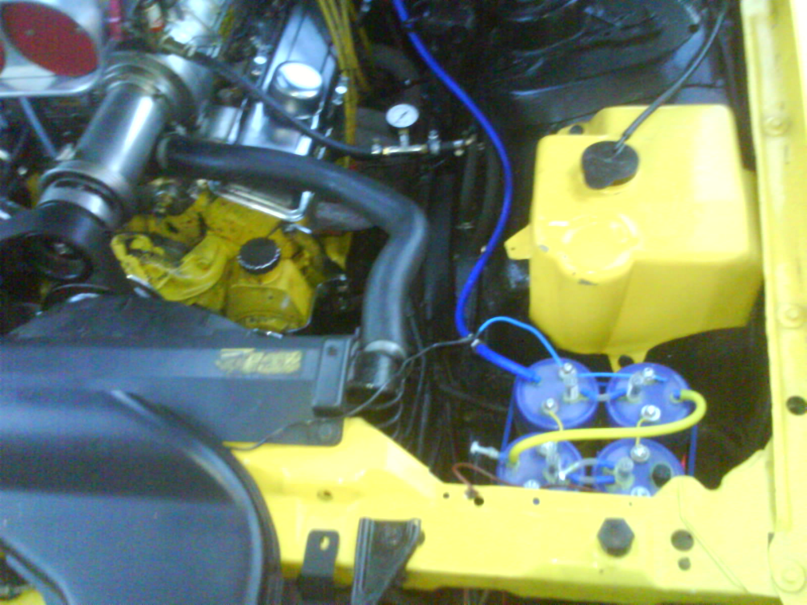
The standard system will take approximately 30 minutes to install after practice.

Before planning the installation of the system it is recommended that you firstly check the amount of electrolyzers you will need and secondly where you are going to install them. If there isn’t enough space within the engine then the system will need to be fitted in the boot / trunk.

It is strongly recommended that you take your time in the first instance and that each step is followed correctly.

The system must be installed in a well lit and ventilated workspace and that all safety precautions are taken. Failure to follow the manual and installation instructions can lead to serious consequences and least of all if incorrectly made or fitted the systems may not produce the optimum output.

TYPES OF KITS REQUIRED

Water4gasuk Ltd has simplified the types of kits that are required for vehicles. They are as follows:

Standard Kit – This kit is for all diesel engines regardless of age or engine size. It is highly recommended that for each 1000 cc, there is a minimum of 1 Electrolyzer, up to the optimal amount of 6 as can been seen in the chart below. The standard kit is also recommended for any petrol/gasoline vehicle which is none injected and without an oxygen sensor older than 1992 again using the same principle of one Electrolyzer per 1000 c.c Minimum.

(Please be aware that Water4gasuk Ltd’s standard kits already contain one Electrolyzer)

Engine Size | 1.0 | 2.0 | 3.0 | 4.0 | 5.0 | 6.0
Electrolyzers required | 1+ | 2+ | 3+ | 4+ | 5+ | 6+

Petrol/Gasoline injection engines newer than 1992 with an oxygen sensor – These vehicles require the standard pack plus an Oxy Isolator. If the vehicle has two oxygen sensors before the catalytic converter on it, then two Oxy Isolators will be required

What do I need to install the kits?

Tools required for installing the kits:

INSTALLING THE KITS
DRILL
6MM DRILL BIT
WIRE STRIPPER/CRIMPS
22MM oxygen sensor spanner (PETROL/GAS ONLY NEWER THAN 1992)
12v ELECTRICAL TEST LIGHT

The Electrolyzer. This is the “powerhouse” of the system. The contents are an Electrolyte, which is Sodium Bicarbonate, (otherwise known as baking soda or bicarbonate of soda) in water. In most cases (UK) tap water is sufficient however if you have a lot of lime scale in the water from the tap it is recommended that Distilled water is used. This can be purchased from any good health food store
The Electrolyser is operated by vacuum pressure from the vehicle’s engine and power from the vehicle’s 12v electrical system.
The electric current combined with the Electrolyte produces hydrogen. Hydrogen is normally very dangerous, but our system is completely safe because it is a “hydrogen on demand” system (meaning hydrogen is only produced when required). NO hydrogen is stored in large amounts, hydrogen production stops as soon as the ignition is switched off. Hydrogen (in the form of HHO) remains safely suspended in the water and does not become combustible until power is restored again.

Our system is safer than the petrol, diesel or LPG systems you will be used to dealing with.

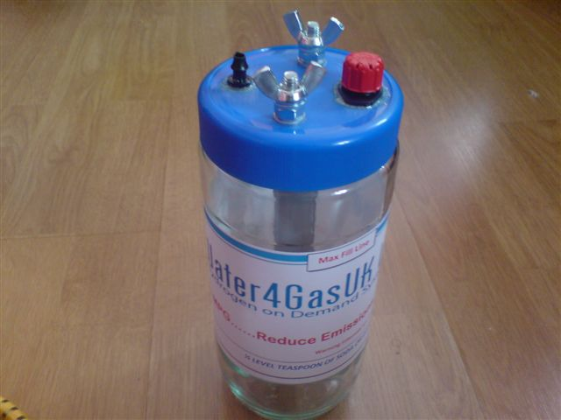

INSTALLTION INSTRUCTIONS

Before planning the installation of the system it is recommended that you firstly check the amount of electrolyzers you will need and secondly where you are going to install them in a secure upright position. If there is not enough space within the engine bay then the system can be securely fitted upright in the rear of the vehicle*. *(A longer vacuum tube and automotive wire will be required)

Water4gasuk Ltd recommends that there is a minimum of 1+ Electrolyzer per 1000.c.c for there to be noticeable results. However a 6 Electrolyzer system will give greater gains in MPG or Performance, whichever is required.

It is strongly recommended that you take your time in the first instance and that each step is followed correctly.

Wear gloves and goggles as required in the automotive health & safety guides.

Ensure that if anyone is helping you or observing they are aware of the safety procedures and at no time should there be a flame of any description near the system. This also includes smoking.

The system must be installed in a well lit and ventilated area and that all safety precautions are taken. Failure to follow the manual and installation instructions can lead to serious consequences and least of all if incorrectly made or fitted the systems may not produce the output you are aiming to achieve.

Ensure the engine is switched off and is cool prior to installing the system.

PREPARING THE ELCTROLYZER(S)
- Fill the jar with water either tap (if suitable) or distilled leaving a gap of 30mm minimum from the top of the jar, stir well until the soda has completely dissolved

Please note that adding too much soda will result in the system overheating and blowing the fuse. More soda will NOT create more hydrogen

You are now ready to install your Electrolyzer.

STEP 1. INSTALL THE ELECTROLYZER

Using the ELECTROLYZER retaining strap; place the Electrolyser in the engine compartment. It should be placed in the coolest part of the engine as possible and in a well ventilated area. The Electrolyzer should be fastened securely and in an upright position to ensure it does not move whilst the vehicle is moving. The Electrolyser should be placed where it can be easily checked for the water level, topped up with water, removed for cleaning, servicing or inspecting.

IF POSSIBLE, AVOID MOUNTING IN HOT AREAS. There have been no recorded instances of the glass breaking or the lid of the Electrolyzer melting in extreme temperatures. Water4gasuk Ltd have also carried out numerous tests and at no point have there been any adverse reactions or damage to the vehicle or system due to overheating

STEP 2 MAKE THE VACUUM CONNECTION

Identify the air intake tube. This will look similar to the one in the picture. With the drill make a hole in the intake pipe to suit the width of the vacuum hose. Make sure no particles from the drilling fall into the air inlet tube.
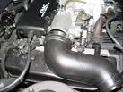
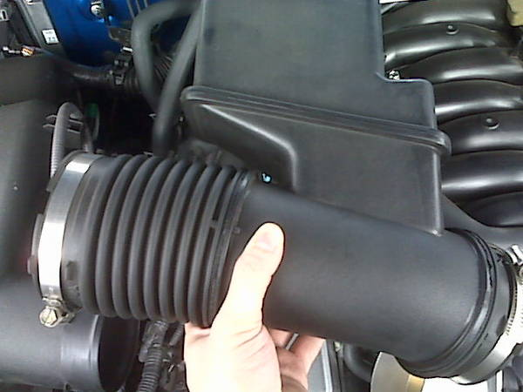

Step 3

Connect one end of the vacuum hose to the Algarde elbow on the Electrolyzer and the other end of the hose push it into the hole you have just made in the air intake pipe.

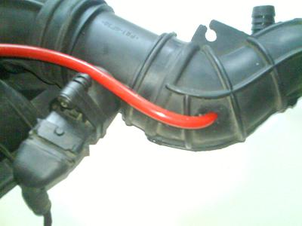
When inserting the hose be sure to push the pipe in at an angle as this creates suction known as a Venturi and helps to draw the hydrogen from the Electrolyzer.
AIRFLOW TO ENGINE

WARNING
To enhance safety and prevent damage to the Electrolyser, the hose between the Electrolyser and the inlet manifold must be at least 1m long.

STEP4 . ELECTRICAL CONNECTIONS

Turn the engine key to position ON – This is where the dashboard lights illuminate. DO NOT start the engine at this point.

Using the test light locate a switched 12v supply, once found, check the supply is disconnected when the ignition switch is in the acc (2) position. If the wire is still showing a connection find an alternative.

Using the wiring Connect the negative, (black wire) to one of the terminals on the Electrolyzer (the wing nuts) to a feed from the negative terminal of the vehicle battery.
Connect the positive, red terminal to the Electrolyzer to a feed off position 2 of the ignition, taking it through the fuse and fuse holder as shown below.
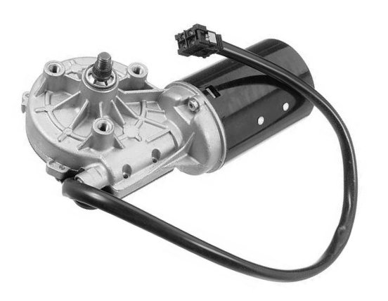
Connect the red wire to any system that gets 12 volts from the position 2 of the ignition switch. The most common system used is the window wiper (as shown)


Fuse
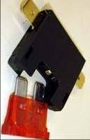
+
-

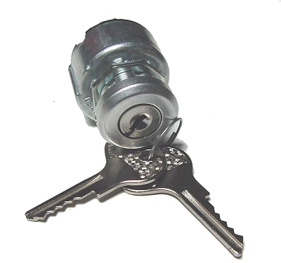

Ignition Switch
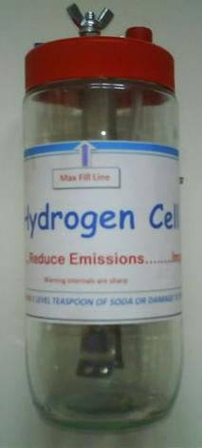

STEP 5. ADJUSTMENT
- Check connections and remove all tools away from moving parts. Start the engine and watch the electrolyzing action between the electrodes. You should see HHO “fizzing” off the electrodes and flowing towards the top of the Electrolyser. For the first time the cell is used from new allow approx 15 minutes for the electrode to hit optimal performance.
- The engine's RPM may be unstable for a couple minutes. This is normal as the HHO is starting to change the combustion cycle and cure any possible pinking. Within roughly 30 minutes, the Electrolyzer will be at its optimal performance, and the engine should start to sound smoother and quieter.
The installation of the system based on one Electrolyzer is now complete.
ADDING ADDITONAL ELECTROLYZERS
To add additional Electrolyzers simply follow the instructions for making the Electrolyzer, please note that the tubing which is used inside the first Electrolyzer isn’t required in any subsequent ones. Remove the red cap from the extra Electrolyzers fitted. This allows the vacuum hose to be connected directly into the dripper.
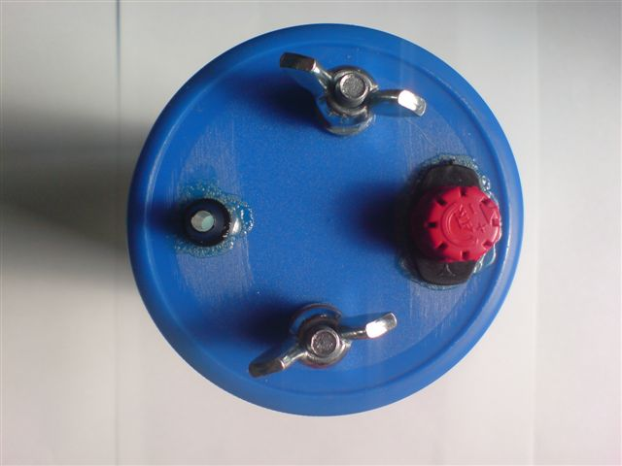
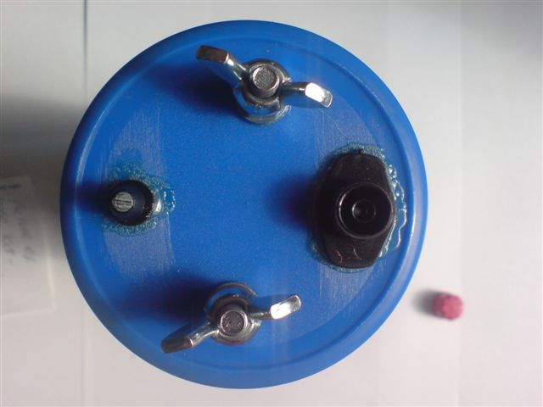

Although a single-cell system should give excellent improvements in MPG, and reductions in emissions, adding additional Electrolyser units or “cells” can make further gains of 20% or more. Cars or vans would benefit from six electrolysers. Trucks and coaches need to start at six and can go up to as many cells as a required.

It also has the additional advantage that the Electrolyzers run much greater distances without the need to top up the water, and even may not need topping up between services.

The vacuum hoses are connected from cell to cell so that the air drawn into the engine passes through each Electrolyser, picking up more and more HHO on the way, as shown on the next page:

Vacuum connection
HHO out to Engine

The diagrams below show the electrical connection between the cells:
+
-
2 Electrolyzer System

+
-
4 Electrolyzer System
This is the safest way to link the Electrolyzers electronically. When the engine switches on the water acts as a conductor and completes the circuit

-
-

+

This is the safest way to link the Electrolyzers electronically. When the engine switches on the water acts as a conductor and completes the circuit
6 Electrolyzer Systems

POSITIONING THE MULTI-CELL
While the Electrolyzers are shown side by side in the diagrams, they can be grouped in any configuration, so long as the vacuum hoses and electrical connections are as shown.
The front area of many cars and trucks is the most convenient area for installing a multi-cell. Six cells will probably fit nicely in a line just in front of the radiator. Some of the air to the radiator would be blocked, but not all if you leave some space between the cells. The air stream will then curve itself around the cells and reach the radiator. As the system makes the engine run cooler, there should not be a problem with some blockage of air stream.

If more than 6 cells are fitted:
- Test the alternator to ensure it can take the load, and protect each series-array with its own fuse.
- Make sure the wiring is thick enough for the job.
- Test the vacuum pressure. The vacuum created by almost any vehicle should be enough to “pull” up to 6 cells. If it is not, either reduce the number of cells or fit a pump. If a pump is fitted, add a one way valve at the output of each series-array and connect all into one big output after the valves. Then feed this output into the air filter.

OXY ISOLATOR

The oxy Isolator is required for injection petrol/Gasoline vehicles with an oxygen sensor fitted, Newer than 1992.

The Oxy Isolator removes the probe of the oxygen sensor out of the flow of gasses, allowing the Hydrogen to pass through the computerised system without it being detected by the vehicles computer. The Oxy Isolator removes the need for the full electronics kits which are advertised with other organisations.
(Extra drilling to the isolator may be required to fit some vehicles)

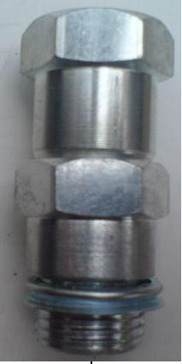
Fitting the Oxy Isolator

Remove the Oxygen Sensor (Lambda Sensor) from the exhaust.

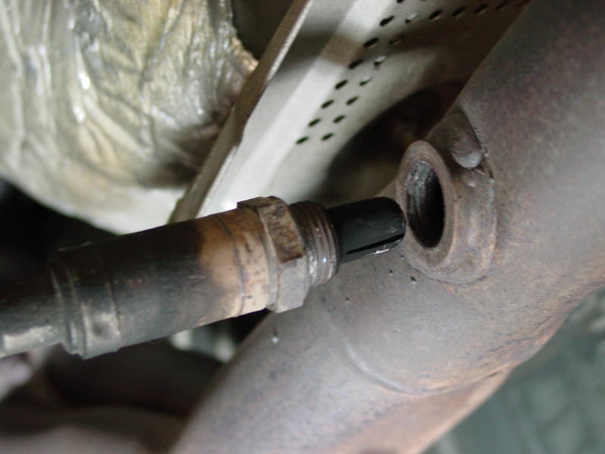

Screw the Oxy Isolator into the exhaust and then screw the Oxygen Senor into the Oxy Isolator.

Ensure that safety precautions are taken:
Wear goggles in case of rust or debris falls from the exhaust
Wear Gloves
Adhere to Health and Safety at ALL times

